Observing attenuation effects on correlation and noise significance various channels

* Herman Li
* 4/5/22

Building on the set up to the previous “Determining the Better Equipment and Data Analysis of the Corresponding Equipment” report, a Beam Splitting attenuation (half waveplate) is used to allow attenuation of the laser pulse. The half waveplate allows horizontally polarized light to pass, by rotating the half waveplate by a certain degree (ϑ) changes the orientation of the incoming beam by 2ϑ. This is added in between the 532nm green laser and the first optical mirror. In addition, a line pass filter is added in front of the dichroic mirror to filter out undesirable background radiation and ambient light.

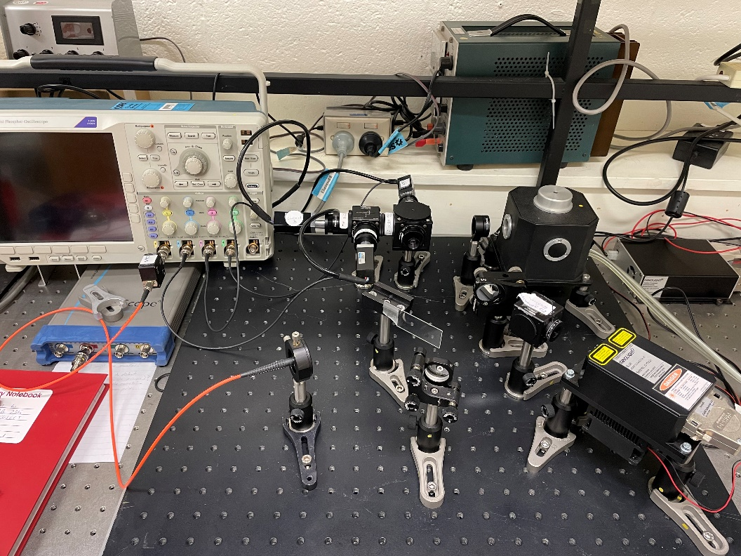The setup is shown below and the added components are labelled accordingly:

Line Pass Filter

Beam Splitting Attenuation

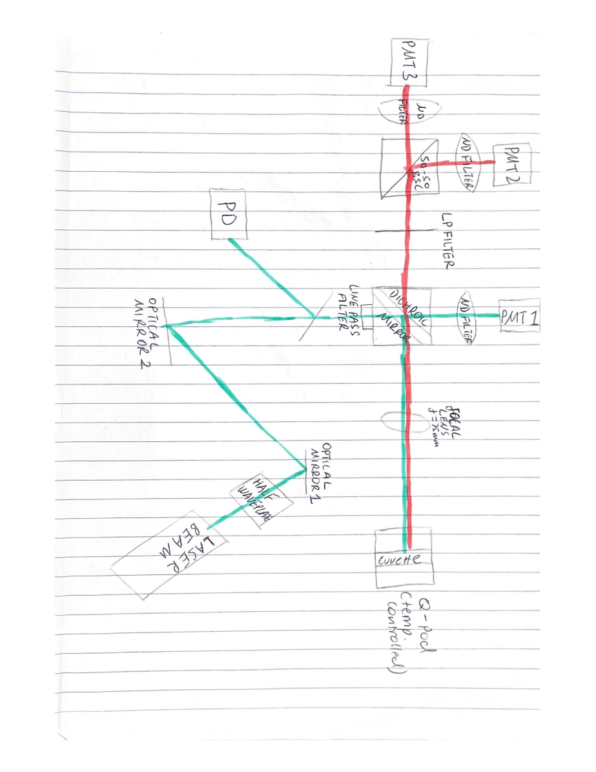

The equivalent and updated schematic diagram is shown below:

In this experiment, 7 averaged data files were taken from no attenuation to max attenuation and had the corresponding trigger levels (224mV,224mV,133mV,95mV,70mV,53mV,26mV). The trigger levels must stay above the small pulses (which are emitted by the laser) and therefore must change because as the attenuation increases, the excitation pulse reduces in intensity.

Below is a plot showing the correlation between peaks across various channels as the attenuation increases:

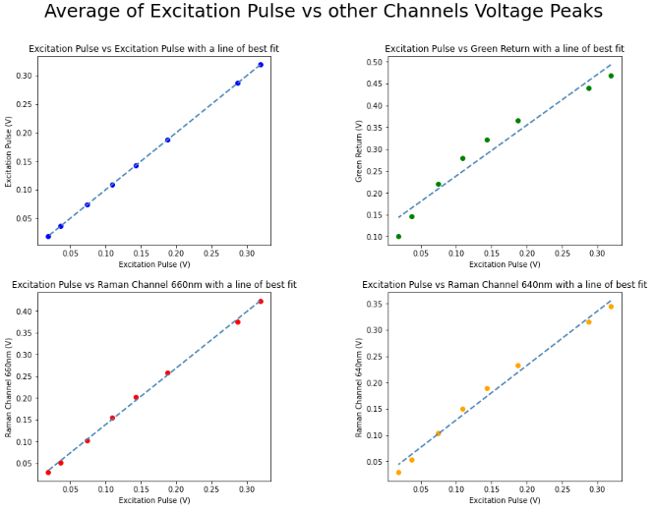The dotted line is a line of best fit.

The top left subplot is the excitation pulse measured against itself with varying excitation pulse peaks due to attenuation, hence the perfect linear relationship. This is used to check that there are no issues with the data collection and there doesn’t seem to be.

The top right subplot shows the variation of the Green return channel peaks with varying excitation pulse peaks due to attenuation. It is obvious that it deviates by a certain margin from the best fit line but not so much such that it might just be possible to attribute that to noise. Although it must be pointed out that from the limited data taken, the curve is suspiciously cubic-like.

The 2 bottom plots symbolise the Raman return channels (left – 660nm and right 640nm) against excitation pulse with increasing attenuation. It is possible to argue that the Raman 660nm return channel is almost perfectly linear, so perhaps the minimal variation can be attributed to noise. Although it does look like it may be a perfect linear fit, it does also possess the same cubic like shape, which is slightly worrying. The exact same kind of situation is happening for the Raman 640nm return channel and the deviations and cubic shape is a little more pronounced than the Raman 660nm channel, but not as bad as the Green return channel.

Whether the deviation is of true concern or just due to uncertainties is up for speculation.

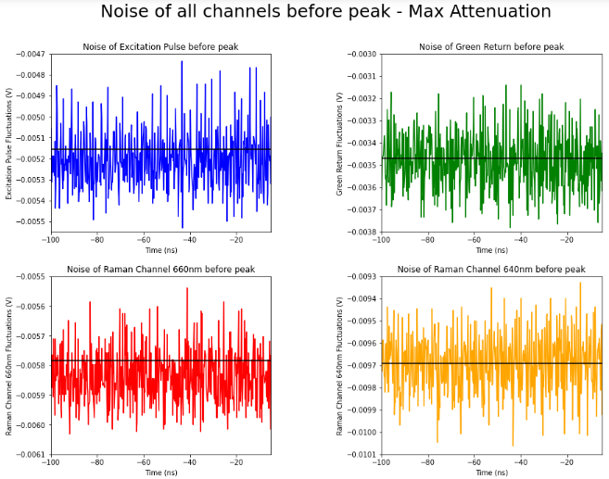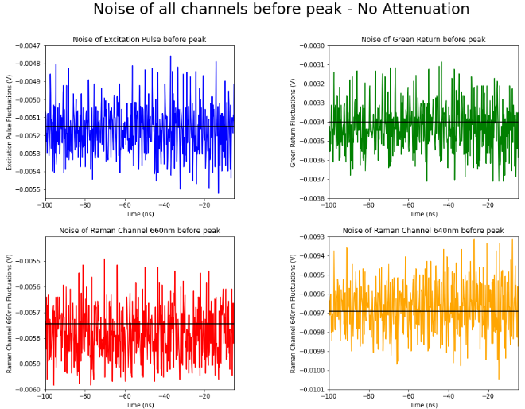Next, we examine noise before and after the pulse detection. Below are plots of the noise level before the pulse detection with no attenuation and maximum attenuation respectively, the black horizontal line represents the baseline, equidistant from the largest peak to peak of the noise.

Expectedly, the attenuation shouldn’t affect the noise level. The noise itself is not too significant as the largest difference (peak to peak) is only 0.00083V (or 83mV) and the average value for each corresponding graph stays almost the same.

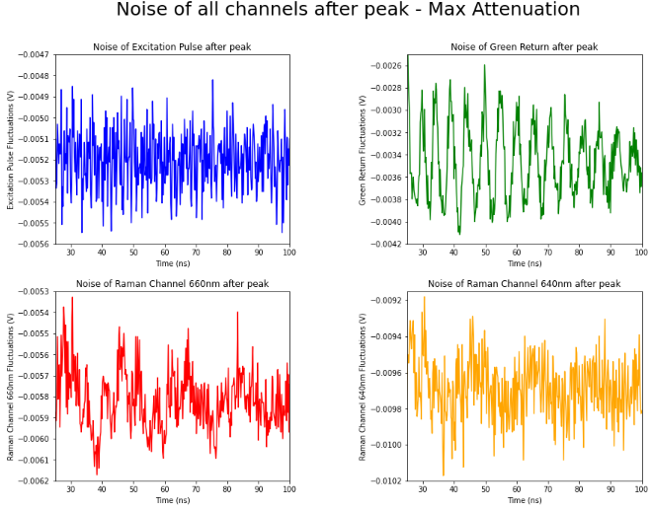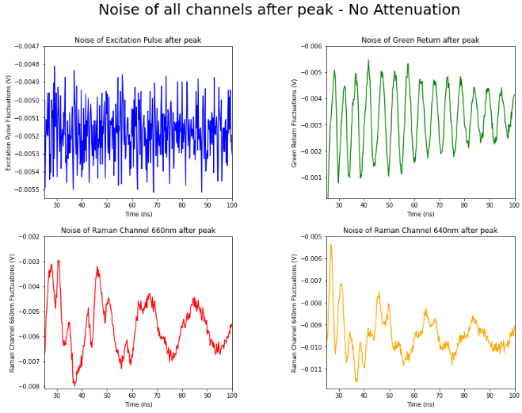A similar event is true for the noise signals after the peak. The plots are shown below:

Again, it doesn’t seem like attenuation has affected the noise level, the two plots are very similar except that the plot with maximum attenuation looks like a muffled version of the plot with no attenuation – the noise looks a little more supressed at max attenuation, this could be because the noise signal is so small that the signal just moves between individual bin levels, the general oscillation doesn’t change much, but becomes a little more noisy. Here, we can also graphically see that there is much more noise variance after the detection of the peak due to the infinite amount of uncertainties that have been increased due to that detection such as instrumental uncertainties from PMT’s, oscilloscope and PD’s, but the overall noise decreases compared to noise before the pulse, possibly in line with the reduction input intensity.